FIRE BEHAVIOUR ADVISORY - CARIBOO FIRE CENTRE
Date issued: Friday, May 24, 2021
>>>A Fire Behaviour Advisory is in effect today:<<<
- The advisory is for C3 and slash fuel types in an area around Alexis Creek, Riske Creek, and the Southern portion of the 100 Mile Zone as far Southeast as Young Lake
- The advisory is in effect only during peak burning (1700) where there is potential for intermittent crowning when winds exceed 10 km/hr.
- For slash fuel types there is potential for fire intensity to exceed 10,000 kw/m throughout the day, with rates of spread up to 15 m/min.
- This is a result of low RH values and dry fuels.
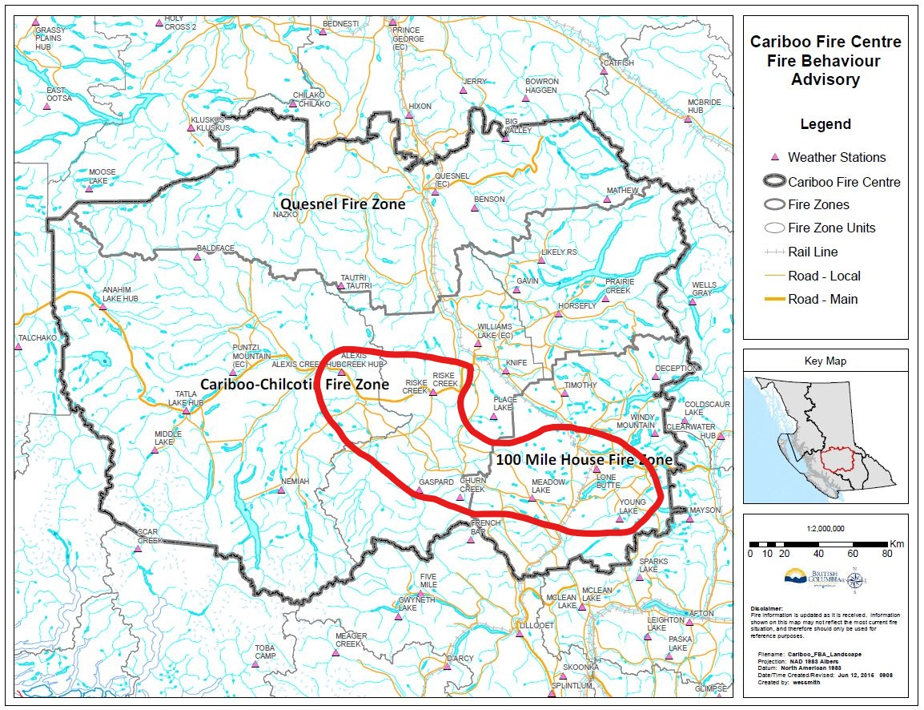
Be aware of local topographic features and their effects on fire behavior. Practice LACES.
>>>Use your red book to make adjustments for your particular on site conditions!<<<

Prepared by: Matt Lees (Fire Behaviour Specialist) Approved by: Doug Yano (RWCO)

Distribution:
CIFAC YWL / CIFAC YPU / 100 Mile House zone / Cariboo Chilcotin East / Quesnel zone / Cariboo Chilcotin West / Teams RO’s /

